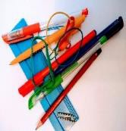

**Maths Functional Skills Initial Assessment**

**Learner`s Name**

**Date of Assessment**

**Score**

**Level**

**Working Towards**

Do **Not** Use a Calculator

|  |  |  |
| --- | --- | --- |
|  | **Work out the answers to the following questions.** | **Answers** |
| **1** | Put these numbers in the correct order.  13 7 19 14 3 8 12 |  |
| **2** | 9  +8 |  |
| **3** | 39  +47 |  |
| **4** | A cafe served 213 lunches on Monday, 281 on Tuesday, 145 on Wednesday, 129 on Thursday and 199 on Friday. How many lunches were served in total? |  |
| **5** | 7 – 4 = |  |
| **6** | Sam is 31, Jordan is 9 years younger. How old is Jordan? |  |
| **7** | 31  x 65 |  |
| **8** | 36 ÷ 4 = |  |
| **9** | 2525 ÷ 25 = |  |
| **10** | Put these fractions in order of size starting with the smallest  3 3 2 2  4 8 6 3 |  |
| **11** | 7 + 99.9 + 0.06 = |  |

|  |  |  |
| --- | --- | --- |
| **12** | In a sale normal prices are reduced by 7%.  The sale price of a tumble dryer is £210 What was the price before the sale? |  |
| **13** | Copper and zinc are mixed in an alloy in the ratio  7 3  copper to zinc  10 10  How much copper is there in 450g of the alloy? |  |
| **14** | 81 – ( 42 + 7 x 8 ) = |  |
| **15** | What time does the clock show? |  |
| **16** | Mark the following temperatures on the thermometer.   1. 320F 2. 600F 3. 220C 4. 580C |  |

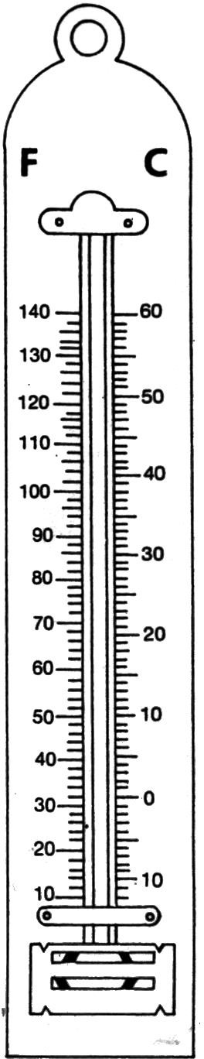

|  |  |  |
| --- | --- | --- |
| **17** | **Fish and Chip Shop Prices**  Cod -small £4.10  Cod -medium £4.80  Cod -large… £5.75  Plaice £4.80  Fishcake £1.70  Chicken portion £4.40  Meat pie £2.70  Veggie Burger £3.50  Pancake roll £1.90  Chips – small £2.20  Chips – large £5.10  Curry sauce tub £1.30  What does a medium cod, a large portion of chips and a curry sauce tub cost in total? |  |
| **18** | Change 2456 cm to metres (m) |  |
| **19** | Calculate the volume of this shape. State the units.  16mm  20mm  24mm |  |
| **20** | What is the area of this shape to two decimal places? State the units.  4.4cm |  |

12mm

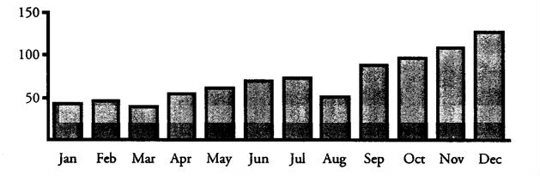

**21**

Complete the chart below

|  |  |  |  |  |
| --- | --- | --- | --- | --- |
| **Production**  **Line** | **Boxes Produced** | | | **Total** |
| 1 | ~~IIII~~  ~~IIII~~ | ~~IIII~~  II | ~~IIII~~ |  |
| 2 | ~~IIII~~ | ~~IIII~~ | ~~IIII~~ |  |

**22**

|  |  |  |
| --- | --- | --- |
| **Factory** | **Football League** | |
| Browns Unit | **0 - 0** | Green Company |
| Bara Bakery Unit | **1 - 2** | Berry Products |
| SMT | **0 - 1** | Yellow Inc |
| Horittts Ltd | **2 - 1** | Ganners |
| Glook Plans | **1 - 0** | KTP |
| Barnes Barns | **1 - 1** | Malcolm Ovens |
| Red Unit | **2 - 0** | Guppas |
| Lobble Inc | **3 - 0** | HYV Purple |
| Lavis Brothers | **0 - 1** | Silop Products |
| ZPQ and Partners | **1 - 0** | Jissops |

How many teams scored 2 goals?

**23** Number of Reported Injuries to Children in the Home

Ten thousands

What is the trend of reported injuries to children in the home throughout the year?

**24**

There are 24 sweets in a bag. Four sweets are mint toffees.

Two sweets are humbugs. Three sweets are lemon jellies. One sweet is picked at random. What is the probability of picking a lemon jelly? Give your answer as a fraction.

**25** Below are the weekly takings for six shops in a High Street.

|  |  |  |
| --- | --- | --- |
| £43 995 | £68 750 | £109 500 |
| £125 000 | £17 000 | £368 995. |

Calculate the median for this set of data?

|  |  |  |  |  |  |
| --- | --- | --- | --- | --- | --- |
| **Production**  **Line** | **Boxes Produced** | | | | **Total** |
| 1 | IIII | IIII IIII | IIII | II | **22** |
| 2 | IIII | IIII IIII |  |  | **15** |

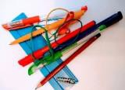

|  |  |  |
| --- | --- | --- |
| **Student Name** | | |
|  | **Work out the answers to the following questions.** | **Mark** |
| **1** | Put these numbers in the correct order. **3 7 8 12 13 14 19** |  |
| **2** | 9  +8  17 |  |
| **3** | 39  +47  86 |  |
| **4** | A cafe served 213 lunches on Monday, 281 on Tuesday, 145 on Wednesday, 129 on Thursday and 199 on Friday. How many lunches were served in total? 967 |  |
| **5** | 7 – 4 =3 |  |
| **6** | Sam is 31, Jordan is 9 years younger. How old is Jordan? 22 |  |
| **7** | 31  x 65  2015 |  |
| **8** | 36 ÷ 4 = 9 |  |
| **9** | 2525 ÷ 25 =101 |  |
| **10** | Put these fractions in order of size starting with the smallest.  2 3 2 3    6 8 3 4 |  |
| **11** | 7 + 99.9 + 0.06 = 106.96 |  |
| **12** | In a sale normal prices are reduced by 7%.  The sale price of a tumble dryer is £208.32 What was the price before the sale? £224.00 |  |
| **13** | Copper and zinc are mixed in an alloy in the ratio 7 copper to 3 zinc  10 10  How much copper is there in 450g of the alloy? 315g |  |
| **14** | 81 – ( 42 + 7 x 8 ) = 9 |  |
| **15** | What time does the clock show? 08:00 or8am |  |
| **16** | Mark the following temperatures on the thermometer. |  |
| **17** | What does a medium cod, a large portion of chips and a curry sauce tub cost in total? £11.20 |  |
| **18** | Change 2456 cm to metres (m) 24.56m |  |
| **19** | Calculate the volume of this shape. State the units. 7680mm3or7.68 cm3 |  |
| **20** | What is the area of this shape to two decimal places? State the units. 60.79cm2 |  |
| **21** | Complete the chart below |  |
| **22** | How many teams scored 2 goals? 3 |  |
| **23** | Number of Reported Injuries to Children in the Home  What is the trend of reported injuries to children in the home throughout the year? Injuries to children increased gradually throughout the year but lowered in August.  *(answer must include gradual increase and dip in August for mark* |  |
| **24** | There are 24 sweets in a bag. Four sweets are mint toffees. Two sweets are humbugs. Three sweets are  lemon jellies. One sweet is picked at random. What is the probability of picking a lemon jelly? Give your answer as a fraction. 1/8 |  |
| **25** | Below are the weekly takings for six shops in a High Street.£43 995 £68 750 £109 500 £125 000  £17 000 £368 995.Calculate the median for this set of data? £89,125 |  |
|  | **TOTAL** |  |
|  | **LEVEL** |  |

|  |  |
| --- | --- |
| **Score** | **Level** |
| 0-5 | Entry 1 |
| 6-10 | Entry 2 |
| 11-15 | Entry 3 |
| 16-20 | Level 1 |
| 20-25 | Level 2 |