Initial Self-Assessment (BASIC)

|  |  |  |  |  |
| --- | --- | --- | --- | --- |
| Tick | | | Yes | No |
| Did you receive additional help at school - reader or scribe for exams, extra time in exams, dyslexia support or 1 – 1 support? | | |  |  |
| Do you have a transition plan or Education, Health and Care plan? | | |  |  |
| Are you under the care of Social Services or in care? | | |  |  |
| Are you a carer e.g. for a parent, partner, sibling, child with a disability? | | |  |  |
| Do you have any difficulty/disability which the organisation needs to consider when dealing with the application so we can arrange any reasonable adjustments?  Please provide details here: | | |  |  |
| **Functional Skills (if appropriate)** | **Numeracy & Literacy assessment and other Qualifications**  My highest level of Numeracy qualification is Date of Qualification: My highest level of Literacy qualification is: Date of Qualification: | | | |
| Initial assessment results: Numeracy: Diagnostic assessment results: Numeracy: | Initial assessment results: Literacy: Diagnostic assessment results: Literacy | | |
| Initial assessment results: ICT: Diagnostic assessment results: ICT: | Assessment not completed | | |

How do you rate your: (**1 = low 4 = high)**

|  |  |
| --- | --- |
| If the learner is not able to complete the below, please complete it  on the learner’s behalf to the best of your knowledge. | IAG |
| Your confidence | 1 2 3 4 |
| Ability to speak confidently with others | 1 2 3 4 |
| Ability to work with others | 1 2 3 4 |
| Ability to understand things | 1 2 3 4 |
| Ability to concentrate | 1 2 3 4 |
| Ability to use electronic learning devices | 1 2 3 4 |
| **Knowledge of Fundamental Values** | 1 2 3 4 |
| **Internet Safety** | 1 2 3 4 |
| **Literacy and Numeracy** | 1 2 3 4 |

|  |
| --- |
| **Health** |
| To enable us to plan our first aid provision and to ensure your welfare please would you answer the following questions:  Are you taking any medication that any first aider or doctor would need to be aware of?  ……………………………………………………………………………………………………….  Is there any information we may need to ensure your safety (colour blindness/hearing impairment/learning difficulties/physical disabilities)? |

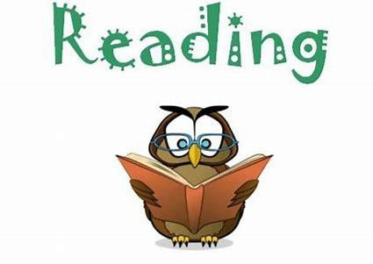

Why are you doing this programme of learning?

|  |  |  |  |  |  |
| --- | --- | --- | --- | --- | --- |
| To learn something new |  |  | To meet new people |  | To have fun |
|  |  |  |  |  |  |
| To gain a qualification |  |  | To gain confidence |  | To get a job |
| Other *(please specify)* |  |  |  |  |  |

|  |  |  |  |  |
| --- | --- | --- | --- | --- |
| **How do you like to learn?** | Listening | Watching | Doing | Reading |

*Please tick those that apply to you*

|  |
| --- |
| **Area of additional focus** |
| So that we can create a personalised programme to enable you to have the maximum opportunities to achieve your potential are there any additional personal/financial/emotional issues we should be aware of? |
| Signed by learner: |