Name Date Mentor

Delivery Partner Participant ID

Is this the 1st 2nd 3rd

4th 5th+

time you are completing a Progress Star?

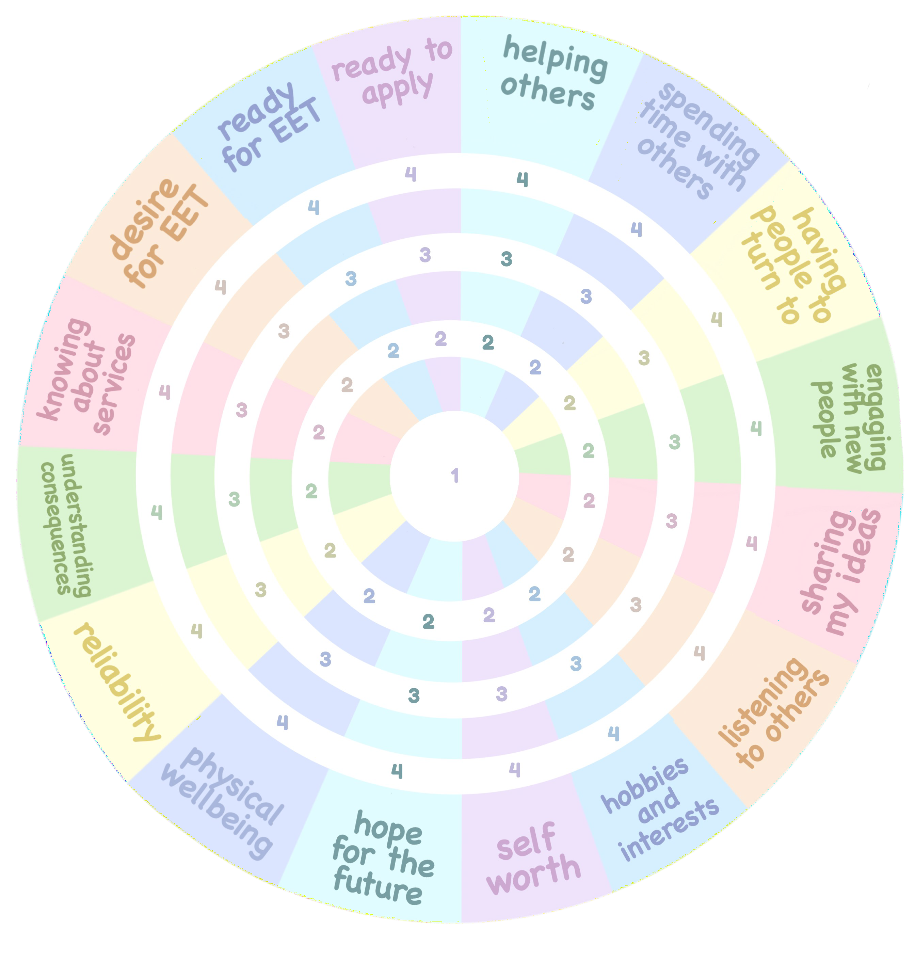

Create a Progress Star