G u i d e to creating a

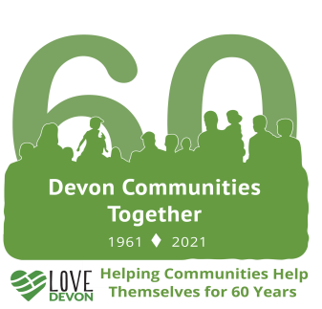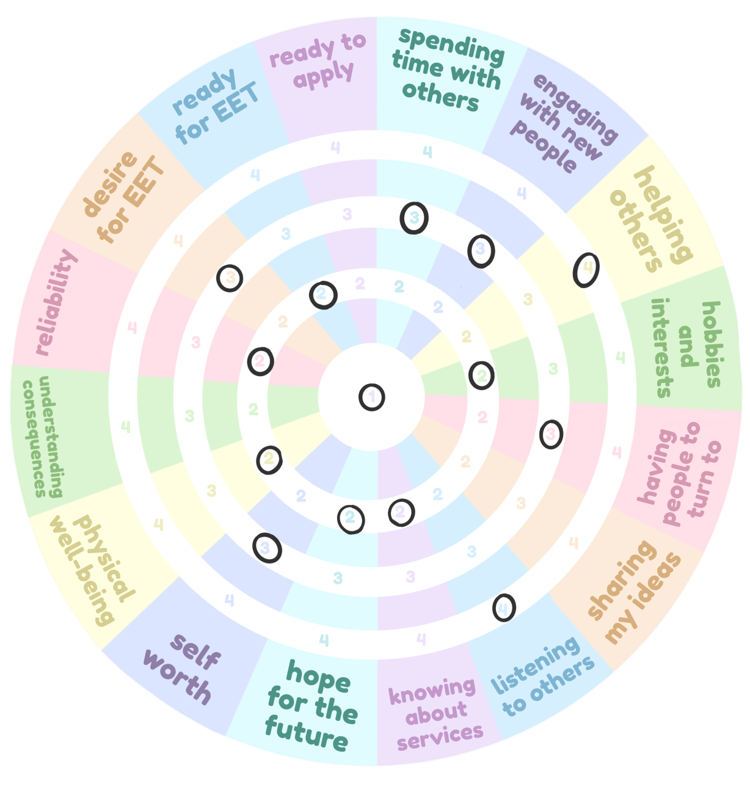

Progress Star

# STEP ONE

Understand why creating Progress Stars can be useful for your journey.

**Progress Stars will help you to better understand three things:**

* **Your Strengths** - celebrate these!
* **Your Weaknesses** - ask your mentor to help you to work on these.
* **Your Progress** - see how your progress changes over time.

# STEP TWO

With your mentor work through the 16 categories.

For each category, decide which of the four state- ments best represents how you think and feel at the moment.

On the Progress Wheel, circle the statement number (1, 2, 3 or 4) that you have chosen for each category, until you have circled a number for every category.

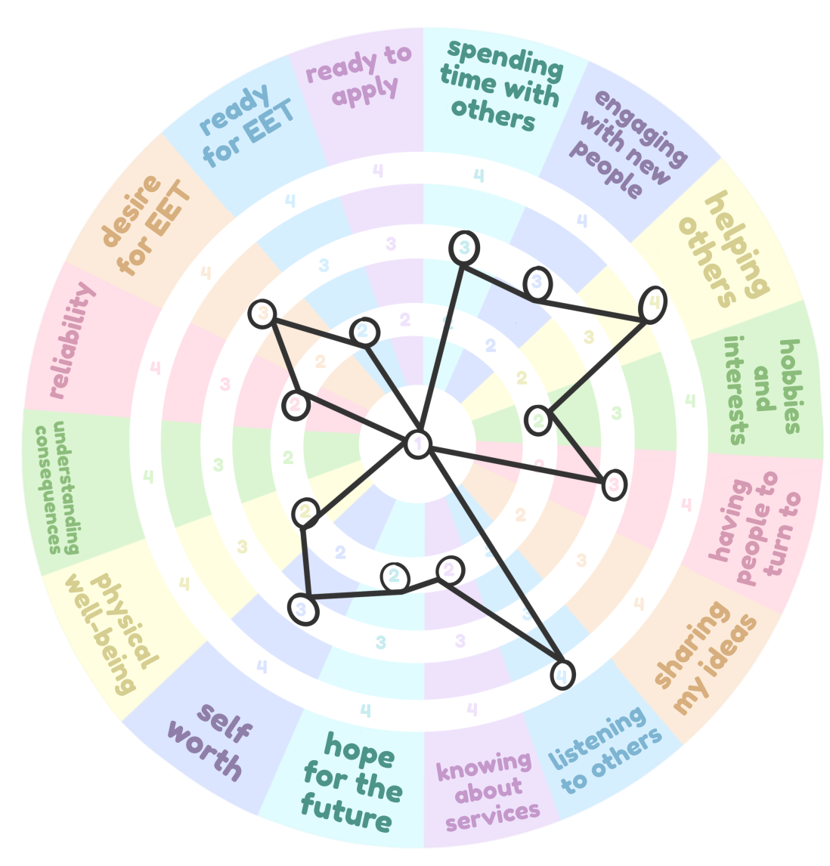Draw lines to connect your circles like a dot-to- dot, working your way around the wheel.

**STEP THREE**

It should look something like this.

**You’ve now created a Progress Star!**

**STEP FOUR**

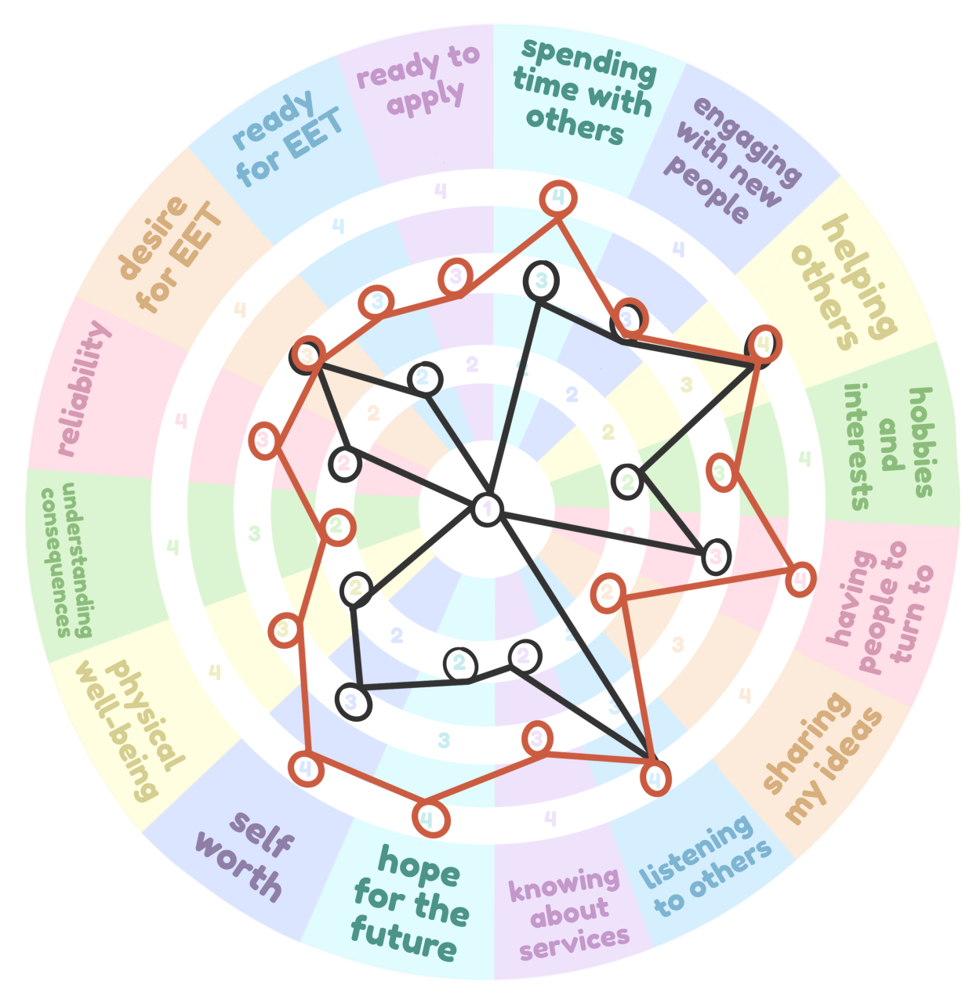*Complete this step in three months, and then again when your time on Experience Works comes to an end.*

Create a new Progress Star by re- peating Step Two and Step Three. This will help you see the progress you have made, since you last created a Progress Star. Your score may go down sometimes - maybe you’ve realised you struggle with something more than you thought. That’s OK and means you’ve improved your self-awareness! You may want to do this on the same wheel as your first Progress Star. Just make sure you use a different pen. It should look something like this.

For the first four categories, choose from these statements:

I never do this and am not interested in it.

1

2

I would like to do this more, but at the moment I don’t do it very often and find it difficult.

3

4

I do this sometimes and I usually enjoy it.

I really like taking part in things like this and do it as much as I can.

**Spending time with others**

Examples are meeting up with friends; going to a social group; working or volunteering with team mem- bers or colleagues; working or volunteering with customers or clients; attending support sessions or

meetings; spending quality time with family members.

Examples are trying out new social groups; beginning a new job or volunteering role where you have to talk to new team members, colleagues, clients, or customers; getting to know new people when attending courses.

**Engaging with new people**

**Helping others**

This includes anything where you are trying to help someone else or make a change to the world around you. For example volunteering for a charity; helping a neighbour with shopping or pet-sitting; taking part in a campaign for change; supporting a friend or family member through a difficult time.

Examples are sports, painting, knitting, dancing, technology, being outdoors, reading, music, cooking, photography, and much more.

**Hobbies and interests**

Do you have people in your life who you feel close to? Would you feel comfortable turning to them if you

**Having people to turn to**

were having a difficult time?

I feel like there is no one in my life that I can talk to about my problems.

1

I think there might be one or two people who I could talk to about my problems, but I’m not sure.

2

I can think of one person that I would feel comfortable turning to if I was having a difficult time. I feel close to this person.

3

4

I can think of more than one person that I would feel comfortable turning to if I was having a difficult time. I have at least a few people I feel close to.

**Sharing my ideas**

How comfortable are you telling people your thoughts, opinions and ideas? This includes talking in per- son, on video call or the phone, and sending emails, texts or other messages

I don’t like talking to other people in person or through technology. I do this as little as possi- ble and find it very difficult.

1

2

I struggle to communicate and talk my ideas through with other people., but I still give it a go.

3

4

I’m getting better at talking my ideas through with other people but would like to improve

these skills even more.

I am confident when communicating my ideas to others, in lots of different ways.

Do you pay attention to what other people think and feel? Do you make sure other people are given the

**Listening to others**

time and space to share their opinions?

I am not interested in what other people have to say and do not make an effort to listen to their ideas or opinions.

1

2

I care about other people’s ideas, but find it very difficult to listen to them as I often lose my concentration or get confused.

3

I usually listen to other people’s ideas and opinions, but occasionally I forget to pay attention to what others are saying.

4

I always enjoy hearing other people’s opinions and ideas. I make an effort to show them that I have understood what they are saying.

Examples include libraries, gyms, mental health support, social groups and clubs, financial support, educa- tion providers, employability support.

**Knowing about services**

How many support services in your local area (within 30 minutes of travel) could you name?

0-2

1

2

3-4

3

4

5-7

8+

How do you feel about the rest of your life and the future?

**Hope for the future**

I think it will be really bad and that’s just the way it is.

1

2

I am worried about the rest of my life but think it’s possible that it might turn out OK.

I know there will be some challenges which can be a little scary, but mostly I feel positive about the future and think I will be OK.

3

4

I am excited about the future and what I will do with the rest of my life.

How do you feel about yourself? Do you feel useful or useless? Do you feel you matter and are valuable?

**Self-worth**

I always feel useless and like I don’t matter.

1

2

Sometimes I remember that I matter and feel OK about myself, but I find this difficult.

I often remember that I matter and am valuable. Sometimes I do have a wobble and feel use- less or unimportant.

3

4

I am nearly always confident about my own worth and know that I matter and am valuable.

Do you: exercise at least 3 times per week; sleep between 8-10 hours per night; eat a balanced mix of protein, fruit and vegetables, fats, carbohydrates; shower or bathe daily; and brush your teeth twice per day?

**Physical wellbeing**

I don’t really do any of these things and don’t really care.

1

2

I struggle to do lots of these things but understand why they are important I do most of these things but some of them are hard to do regularly.

3

4

This is very important to me and I try my best to do all of these things as much as possible.

Do you understand the consequences of the choices you make in life? Do you make decisions based on what might happen as a result?

**Understanding consequences**

I usually do things and make decisions in the spur of the moment, and never really think about the consequences.

1

2

I’m aware of the consequences of my actions, but often forget about this in the heat of the moment.

3

I usually think about the consequences of my actions, but sometimes make decisions based on how I feel in the moment.

4

I think very carefully about the consequences before I make decisions or do something.

Can other people rely on you to do what you say you’re going to do? Do you turn up to appointments on time? Do you arrive at appointments prepared?

**Reliability**

I almost always forget to do what I have planned, or choose not to. I often let people down at the last minute.

1

2

Sometimes I do what I’ve said I will do, but sometimes I don’t.

3

4

I often do what I’ve said I will do, but occasionally forget or change my mind at the last mi- nute.

I always stick to the plans I’ve made. Other people can rely on me to do what I have said I will do and I very rarely let people down.

How much you want to get into employment, education or training (e.g. getting a new job, starting a new course or beginning a training programme)?

**Desire for Education, Employment or Training**

I am not interested in doing any of these things.

1

2

I think I might like to do one of these things in the future, but definitely not right now.

Usually I feel like I would like to do one of these things, but occasionally feel like I can’t or don’t want to.

3

4

I really want to do one of these things as soon as possible.

How ready do you feel to start a new job, course or training programme? How prepared are you to do this successfully?

**Ready for Education, Employment or Training**

I am not at all ready to try any of these things, let alone do them successfully.

1

2

I think I will be ready to do one of these things within the next 12 months, but I’m not sure how well it will go.

3

4

I think I will be ready to do one of these things soon, but feel there’s more I need to do first, to make sure I can do it well.

I feel totally ready to do one of these things and am confident that I can do it well.

Do you know what employers are looking for in a good job application? Have you used the Employment Key and prepared a CV? Do you know how to present yourself well at an interview? Have you practiced interview skills?

**Ready to apply**

I haven’t done any of this and wouldn't know where to start.

1

2

I’m aware of some of the things I need to prepare for this process, but have a lot more pro- gress to make before I could apply for anything.

3

4

I have some of the skills I need to complete a job application or attend an interview, but there is more I could do to build my confidence around this.

I feel totally prepared and ready to complete a job application to a high standard and I would be confident to have an interview with an employer now.