**Passport to Employment.**

Name;

Mentor;

Welcome to your preparation to employment, we will be working together to make sure work works for you. The points below can be completed in your own time and during sessions with your mentor.

|  |  |  |  |
| --- | --- | --- | --- |
| Activity | Completed on | Checked by | Notes |
| 1. Routine Health-check |  |  |  |
| 1. What it means to be employed – are you ready? |  |  |  |
| Who are you and what do you have to offer employability module. * |  |  |  |
| Jobsearching employability module. * |  |  |  |
| Writing a CV* |  |  |  |
| Writing a Covering Letter* |  |  |  |
| Applications* |  |  |  |
| Interview preparation* |  |  |  |
| 1. Working environments |  |  |  |
| 1. Payslips |  |  |  |
| 1. Earnings calculator |  |  |  |
| 6. Understanding the workplace – Structure of organisations |  |  |  |
| Self-advocacy, rights and responsibilities. * |  |  |  |
| 1. Understanding the workplace – Job descriptions and role activities. |  |  |  |
| 1. Mock interviews/Employer encounter. |  |  |  |

1. **Routine Health-check.**

Don’t worry, this is a health check for your routine not a physical health check!

Finding employment is a big step and depending on the job you choose there are different parts of your current routine that you may need to adjust.

Have a look at the below table and make some notes.

|  |  |  |
| --- | --- | --- |
| Routine | Current | Changes to be made? |
| How are you currently sleeping?  Do you go to bed late and get up late or are you normally awake before 8am ready to start the day?  Do you sleep well at night? |  |  |
| When you get up in the morning what is the first thing you usually do? |  |  |
| What is your diet like? Do you eat regularly and would you consider yourself to eat healthily? |  |  |
| Do you have any daytime commitments currently? |  |  |
| Do family and friends rely on you to be available to help during normal working hours? |  |  |
| Do you have any hobbies or activities in your week that you enjoy doing? |  |  |
| Do your friends and family have jobs? |  |  |
| How is your mental health?  Do you have days when getting out of bed is a struggle?  Are you currently receiving any support for your wellbeing?  How do you cope with socialising and new situations? |  |  |

Think about what you may need to do to make a workday easier for you, do you currently stay up in the night to play games or do you currently have a commitment to support family with school runs? Healthy eating, good sleep and a focus on wellbeing are all key components to feeling better when you start work. How can we help you make some changes to make these things easier?

1. **What it means to be employed – Are you ready?**

Talk through the below points with your mentor or someone close to you.

* Why do you want a job?
* How will it improve your life?
* Have you found any changes to make from the routine health check? How easy will these be to make?
* Have you thought about childcare, family commitments, caring responsibilities if necessary?
* What do you hope to gain from being employed?
* How do you normally handle being given instructions?
* Are you happy to join a team of people you don’t know or those you wouldn’t normally choose to spend time with?
* How would you normally control your emotions in difficult team work situations?
* Are you comfortable with asking questions?

1. **Working Environments.**

See the link below, discuss with your mentor the different elements of a working environment. Does this link in with the sector you are applying in? Which example feels most comfortable for you and which feels the least comfortable?

When you arrange your employer encounters would it be useful to see a range of environments?

[5 Types of Work Environments (And How To Find the One for You) | Indeed.com](https://www.indeed.com/career-advice/finding-a-job/types-of-work-environments#:~:text=A%20work%20environment%20is%20the%20setting%2C,significant%20aspects%20of%20a%20work%20environment%3A&text=A%20work%20environment%20is,of%20a%20work%20environment%3A&text=environment%20is%20the%20setting%2C,significant%20aspects%20of%20a)

1. **Payslips.**

Each employer will have a slightly different format for their payslips. The below example shows what you can expect to see. Use the earnings calculator to help you work out what your take home pay will be after deductions.

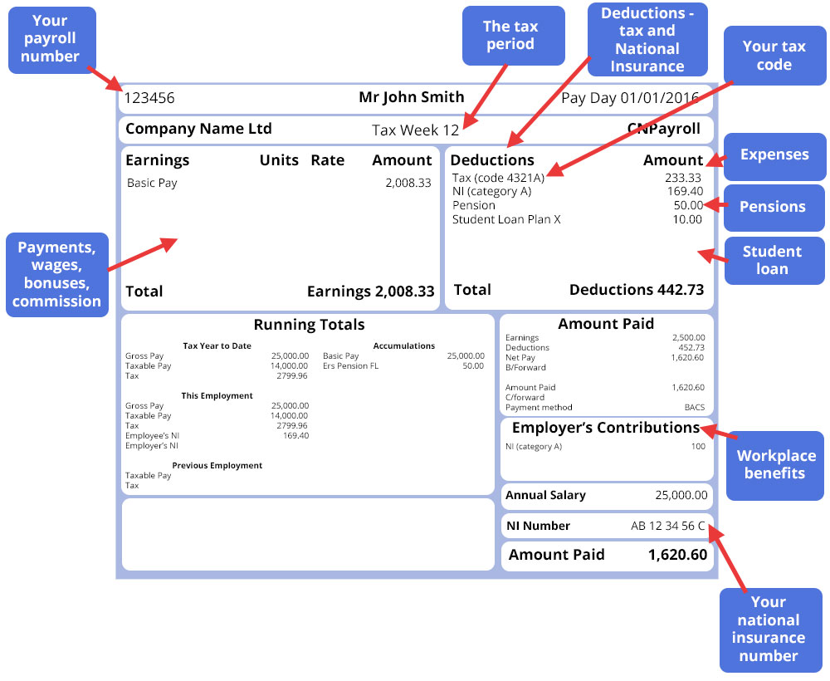

1. **Understanding the workplace – structure of organisations.**

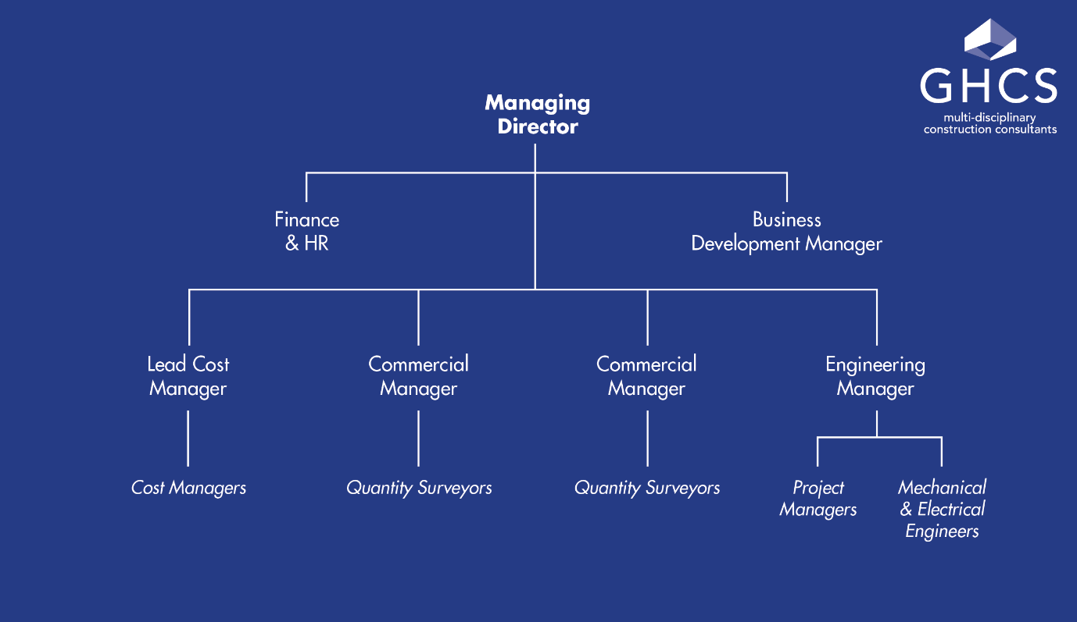In each organisation you work for there will be key staff members to help with certain difficulties or specific people you should go to if you have a question. Typically the structure will look like the below;

Ordinarily your manager or supervisor would be the first person you would approach with any queries, they will be able to help or find the best place to direct the question to.

You can always approach the HR or Finance departments as well if you have any questions around your contract, working conditions, concerns or anything to do with pay or expenses.

When you start a new role part of the induction process should introduce you to different team members and explain their roles.

1. **Understanding the workplace – Job descriptions and Role Activities**

Your mentor will have found several different job descriptions to fit the employment sector you are interested in, look through these together and focus on language used, how much is expected of employees in different roles and whether you think there would be additional duties not listed that you would be happy to complete. Often in a job description there will be a clause which advises additional duties, some of these will come naturally to us and we won’t notice we’re doing them, other times you may need to take on extra responsibilities. This is not always a negative thing as it will show your commitment to the company; to your role and will help you progress in your career.

1. **Mock Interviews/ Employer encounters.**

Now we can move to the final piece in your ready for employment puzzle. With your mentor identify different companies in the local area that you would be happy to visit, arrange to have workplace tours, conversations or mock interviews with them where possible and make notes below.

Your mentor will also set up mock interviews with other members of the mentoring team.