

EQUALITY, DIVERSITY & INCLUSION REPORT

STAFF NOVEMBER 2023

Prepared by Sheena Murphy-Collett
Vice Principal People, Organisational Development & Engagement

EDI Report 2023 (Staff)

Contents Page No.
- Executive Summary 3
- Introduction 4
- 2.1 Terms of Reference 4
2.2 Method of Investigation 4

- The Report 5
3.1 The Staff Profile 5
3.2 EDI – the College’s Positive Actions/Impact 11
3.3 Action Plans 13

- Conclusions and Recommendations 13

- Executive Summary
This report focuses on College staff/workers and 6 protected characteristics of the Equality, Diversity and Inclusion (EDI) agenda – gender, disability, ethnicity, age, sexual orientation and religion or belief.
The College positively encourages applications for employment at the College:
“We are committed to being an equal opportunities employer, always selecting staff on the basis of ability and the requirements of the post, detailed in the Person Specification.”
Having a diverse workforce is important as difference provides creativity, offers a range of perspectives, people have a variety of skills and talents and the fact that inclusivity can raise morale and help with staff engagement.
The College workforce profile can be seen below:
- Gender – the College closely correlates with the FE workforce data for England profile.
- Disability – the College profile is lower than the FE workforce data for England comparator in the sector.
- Ethnicity – the College closely correlates with the FE workforce data 2018-19 and the Census 2021 data sets.
- Age – the College closely matches the FE workforce data for England.
- Sexual orientation – the College closely correlates with the FE workforce data for England and the Census 2021 dataset. Furthermore, the declaration of this data in the College is currently at 82%.
- Religion or Belief – the College has fewer Christians and staff with no religion or belief compared to the Census 2021 data set. There was no data provided in this area in the FE workforce data for England. However, the declaration of this data in the College is currently at 63%.

2. Introduction
2.1 Terms of Reference
This report focuses on EDI data provided on 20 October 2023.
There were 648 permanent staff, fixed term staff and workers engaged within the College. These staff/workers work across the College in all disciplines.
This report focuses on three aspects:
- The College’s statistics for the workforce in terms of gender, age, ethnicity, disability, sexual orientation and religion or belief.
The statistics are captured on the Human Resource database, by the Human Resource team. The data is initially captured during the recruitment process. It is also updated when the Human Resource team are advised, e.g., an Occupational Health report declares that an employee has a disability or by the employee themselves using the self-service facility on iTrent. The Human Resource team also periodically request that staff update their personal information when changes occur.
- The positive actions taken by the Human Resource team in proactively managing the EDI agenda and there impact.
- The action plan to proactively manage EDI at the College.
2.2 Method of Investigation
This report has been written using:
- The knowledge of the Vice Principal People, Organisational Development & Engagement regarding the management of EDI at the College (for staff).
- The data from the human resource database (iTrent).
- Data from:
  - The Devon 2021 Census dataset.
  - The Further Education workforce data for England ‘Analysis of the 2020-21 staff individualised record data’.
  - The Nomis Official Labour Market statistics (provided by the Office of National Statistics - ONS).
This report encompasses the following key EDI protected characteristics – gender, age, ethnicity, disability, sexual orientation and religion or belief.

3.0 The Report
3.1 The Staff profile
Gender
There are currently 429 females and 219 males in the workforce.
Figure 1 illustrates the gender profile for the College workforce.
Fig.1
The College’s gender profile for 2023 closely matches the data for 2022, 2021, 2020, 2019 and 2018.
The Census for 2021 dataset shows the employed gender profile in Devon as: male 49% and female 51%.
The FE workforce data for England from the 2020-21 dataset shows the gender profile for colleges in England as: female 64% and male 36%.
The College gender profile of 68% female and 32% male is closely aligned with the FE workforce data for England.

Disability
There are currently 15 members of the workforce who have declared a disability (there were 21 in 2022) and 633 have not declared having a disability. Figure 2 illustrates the disability profile for the College workforce.
Fig.2
The chart below in figure 3 illustrates the disability type:
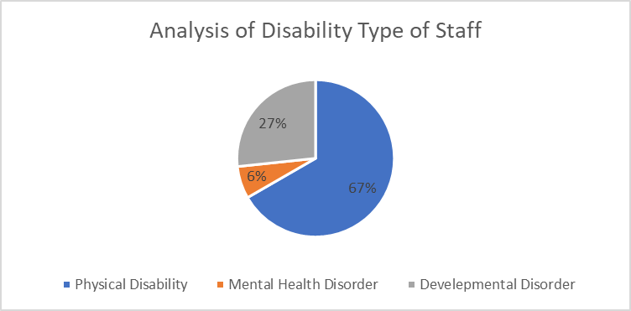
Fig.3
Of the 15 members of staff who declared a disability:
- 4 have a development disorder.
- 1 has a mental health disorder.
- 10 have a physical impairment.
College staff with disabilities make up 2% of the workforce it was 3% in 2022).
The Census for 2021 dataset shows the employed disability profile as being 8.4%.
The FE workforce data for England for 2018-19 dataset shows (there is no recent data available) that over 90% of the FE workforce has no disability and 4% did not declare either way. Therefore, around 6% of the FE workforce have a disability, with physical impairment being the largest category of disability.
The College profile remains lower than the FE workforce data for England dataset and the Census for 2021.

Ethnicity
Out of the 648 total workforce - 575 (89%) members of staff declared that they were White-British. The table in figure 4 illustrates the ethnicity profile of the College workforce over the last 3 years.
Ethnic Origin | Number of Employees 2023 | Number of Employees 2022 | Number of Employees 2021
Anglo Indian | 1 | 1 | 1
Any other Asian background | 2 | 1 | 3
Any other Mixed background | 0 | 1 | 1
Any other White background | 18 | 28 | 19
Any Other Background | 2 | 1 | 1
Any other ethnic group | 1 | 1 | 2
Asian British | 0 | 1 | 1
Asian Chinese | 1 | 1 | 1
Asian Indian | 3 | 1 | 1
Black African | 0 | 1 | 1
Black British | 0 | 1 | 0
Not Stated | 36 | 13 | 16
Prefer not to say | 7 | 6 | 7
White British | 575 | 642 | 696
White Irish | 2 | 3 | 3
White and Black Caribbean | 0 | 0 | 1

Fig. 4
The Census dataset for 2021 shows the ethnic profile as being 88% white British in the Southwest. Therefore, there is 12% black minority ethnic (BME).
The FE workforce data for England for 2018/19 shows (there is no recent data available) the ethnic profile as being 85% white for England. There was no Southwest data. Therefore, there is 15% black minority ethnic (BME).
The College ethnic profile is 89% white (it was 91% in 2022). Therefore, the College BME ethnic profile (at 11%) is close to both the FE workforce dataset (at 15%) and Census 2021 Southwest dataset (12%).

Age
The age profile for the College illustrates that 71% of the workforce are over 41 years of age (it was 69% in 2022). Figure 5 illustrates the age profile of the College staff over the last 3 years.
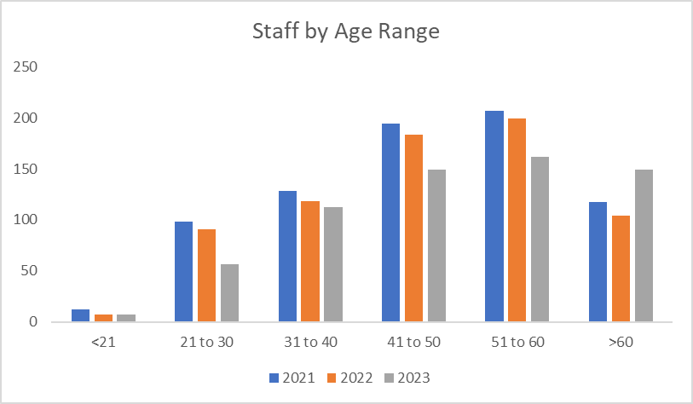
Fig.5
The Census dataset for 2021 shows the age profile as being 51% of working people are 40 years old and above.
The FE workforce data for England dataset for 2018/19 shows (there is no recent data available) the age profile as 69% being over 40 years of age.

The age profile in the College aligns closely with the FE workforce dataset.
Sexual Orientation
There are currently:
- 12 (2% of workforce) lesbian, gay or bisexual (LGB) members of staff,
- 520 (80% of workforce) heterosexual members of staff, and
- 115 (18% of workforce) members of staff chose not to declare.

One member of staff declared as asexual (for the first time) too. Asexual means a person who experiences no sexual feelings or desires, or who is not sexually attracted to anyone.

These figures represent that 82% of the College workforce declared a sexual orientation (it was 88% in 2022). This was regarded as a good declaration level.

Figure 6 illustrates the sexual orientation of the College workforce.
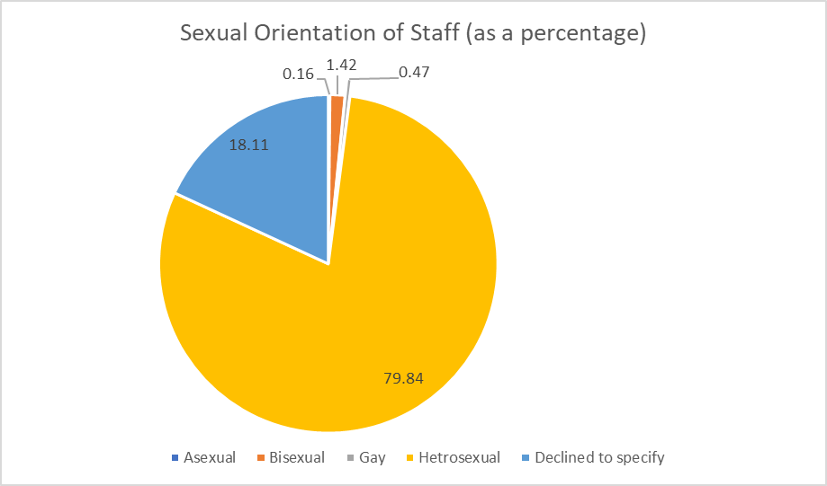
Fig. 6
The Census dataset for 2021 reported:
- 3% lesbian, gay or bisexual (LGB),
- 89% heterosexual,
- 0.23% pansexual (attracted to people regardless of their sex or gender),
- 0.06% asexual,
- 8% chose not to declare.

The FE workforce data for England dataset for 2020-21 included sexual orientation. The data stated:
- 3% lesbian, gay or bisexual (LGB),
- 58% heterosexual, and
- 39% not declared.

The current LGB profile for the College of 2% is close to the FE workforce dataset and Census 2021 datasets of 3%. In addition, due to the levels of non-disclosure (18%), it is worth noting that the 2% may well be higher and in the coming years, as data collection in this area continues, staff may begin to feel more confident in disclosing this type of information, without the worry of this information being inappropriately utilised.

Religion or Belief
There are currently the following religions or beliefs in the College workforce:
Religion or Belief | Staff 2021 | Staff 2022 | Staff 2023
Agnostic | 20 | 19 | 17
Atheist | 31 | 23 | 19
Buddhist – Hinayana | 2 | 1 | 0
Buddhist – Mahayana | 2 | 1 | 1
Christian | 211 | 210 | 181
Christian – Orthodox | 7 | 5 | 4
Christian – Protestant | 7 | 4 | 4
Christian – Roman Catholic | 15 | 15 | 11
Hinduism | 1 | 0 | 0
Judaism | 0 | 0 | 0
Muslim | 1 | 0 | 2
None | 179 | 158 | 161
Other | 9 | 11 | 10
Prefer not to say | 187 | 177 | 238

These figures represent that 37% of the College workforce chose not to declare a religion or belief preference (it was 25% in 2022). These figures represent that 30% of staff declared having no religion or belief. These figures also represent that the largest religion identified at 37% was Christian (it was 33% Christian in 2022).

The Census dataset for 2021 shows the religion or belief profile for the area as being 46% Christian, 37% with no religion and 6% did not state a religion or belief.
There is no FE workforce data for England dataset for 2020-21 for religion or belief for the UK or for the Southwest.

The College religion or belief profile compared to the Census 2021 data has few Christian staff and less with ‘no religion’. However, there were high levels of non-declaration in this area.

3.2 Equality, Diversity and Inclusion – the College Positive Actions and their Impact
The College continues to regard equality, diversity and inclusion (EDI) as a high agenda item. It is intrinsic to all College business. There continues to be a number of positive actions taken to tackle the agenda in a pragmatic and sensitive manner. These include:

Recruitment
All external College recruitment adverts publish the College’s commitment to EDI:
“We are committed to being an equal opportunities employer, always selecting staff on the basis of ability and the requirements of the post, detailed in the Person Specification.”
The recruitment adverts also contain the Disability Confident Employer symbol.

The Human Resource team continue to modify job adverts to encourage applications from people with disabilities.

The Human Resource team also advertise in specific literature where appropriate, for example ABLE magazine for disabled people.

Impact – As a result of these initiatives the Disability Confident Employer standard was successfully reassessed in August 2023.

New Staff
Staff continue to be introduced to the College ethos on EDI during their induction process. This is delivered by means of:
- An induction booklet, containing all key information required for new staff, is issued at their first day induction – it covers EDI at the College. The booklet also contains the fact that the College has the Disability Confident Employer accreditation for being positive about staff with disabilities and supports staff with disabilities through organisations like Access to Work.
- An online training session during their first 6 months. All offers of employment are conditional to staff undertaking the EDI training within their first 6 months.
- An online induction programme, that covers a variety of aspects of being a new member of staff, including the College’s approach to EDI.

Impact – As a result of these initiatives, staff are made aware of and understand the EDI agenda at the College and are signposted to further information.

Policies
The Equality policy in place at the College is regularly reviewed and updated, to highlight the College ethos and approach to the EDI agenda, as well as indicating the action that will be taken in the event that there is a complaint.

There are also other key policies, and these include: Menopause policy, Public Interest Disclosure (whistleblowing) policy, the College Code of Conduct, the Grievance policy, the Disciplinary policy and the Dignity at Work policy. The Dignity at Work policy provides a means for staff to report on a form, incidents of harassment and/or bullying. These policies are reviewed regularly. They are also equality impact assessed, to ensure they do not directly or indirectly discriminate against groups of staff.

Impact – The College communicates and demonstrates a zero-tolerance approach to any form of discrimination. There were no incidents reported about staff in 2023.

Active Management
The College Managers and Human Resource staff continue to work closely to monitor and address a raft of staff issues/concerns. The approach often begins (if appropriate) with informal action initially and then progresses, if required, to more formal proceedings.

The EDI Committee continues to action plan key areas of work, including a new action plan for neurodiversity.

Impact – There have been no bullying and/or harassment matters dealt with informally or formally within the last 12 months.

Training
There is a cycle of activities that are designed to train and educate staff about the agenda. EDI training is regarded as mandatory for all staff and the Human Resource team monitor and report on progress. Staff receive refresher training every 2 years.

The Human Resource team have also, in the last 12 months, facilitated specific training for staff around deaf awareness, neurodiversity, mental health, the menopause and men’s health.

Impact – As a result of this training, staff are made aware of and understand the EDI agenda at the College and are signposted to further information.

3.3 Action Plans
Appendix A contains the completed action plan for 2022/23 and appendix B contains an action plan for 2023/24.

4.0 Conclusions and Recommendations
Equality, diversity and inclusion is regarded as an intrinsic part of Human Resource management at the College. The College has:
- Some good levels of declaration across the strands, with some work to continue to undertake with sexual orientation and religion or belief.
- A representative workforce in most areas, with continued work to do around disability.
- Taken positive and appropriate actions.
- Had a tangible impact with its approach to EDI.
- An action plan that seeks to address the further improvements outlined in this report and any under representation.

Appendices
Appendix A – EDI Action Plan for 2022-23 for Staff
Appendix B – EDI Action Plan for 2023-24 for Staff

APPENDIX A
EDI Action Plan for 2022/23 for Staff
Theme | Key Action | Person Responsible | Outcome
Staff declaration | To encourage staff to declare fully across the strands. | Vice Principal People, OD & Engagement | 100% declaration level are achieved in all areas except sexual orientation (82%) and religion and belief (63%).
Increase the number of staff with disabilities employed at the College. | To target recruitment campaigns.  To engage with staff currently employed with disabilities and seek their views and suggestions on a possible approach. | Head of People Services | The % of staff with disabilities employed has not sufficiently increased, so this action will be a continued focus.
Targeted communication and training are used for EDI themes. | Utilise the EDI calendar to communicate throughout the year, by theme.  Arrange EDI training by protected characteristic. | EDI committee member  HR Administrator – CPD | There has been some effective and timely communications and training around EDI by protected characteristic and work continues.

APPENDIX B
EDI Action Plan for 2023/24 for Staff
Theme | Key Action | Person Responsible | Start Date | Achievement Date | Desired Outcome
To continue to encourage staff to declare fully across the strands. | Utilise ITK to encourage staff to review their personal information to ensure it is correct/up to date. | Vice Principal People, OD & Engagement | November 2023 | August 2024 | Staff information is up to date
 | Encourage staff to declare any areas where declaration is missing, i.e. religion or belief. | Vice Principal People, OD & Engagement | November 2023 | August 2024 | 100% declaration level in all areas.
Increase the profile of younger staff (below 40) | Better harness the social media channels/communication used by younger workers to promote roles in the College. | Head of People Services | November 2023 | December 2023 | Increased workforce under the age of 40.
Increase the profile of younger staff (below 40) | State in job adverts that the College ‘welcomes applications from younger workers’. | Head of People Services | November 2023 | December 2023 | Increased workforce under the age of 40.
Increase the profile of younger staff (below 40) | Promote job roles at the College using case studies of young workers. | Head of People Services | November 2023 | December 2023 | Increased workforce under the age of 40.
Increase the number of staff with disabilities employed at the College. | To continue to target recruitment campaigns within in disability specific spaces (online and printed media). | Head of People Services | November 2023 | August 2024 | The % of staff with disabilities employed increases above 6%.
 | To engage with staff currently employed with disabilities and seek their views and suggestions on a possible approach. | Head of People Services | November 2023 | January 2024 | Staff views sought and harnessed, where appropriate.
Targeted communication and training are used for EDI themes. | Continue to utilise the EDI calendar to communicate throughout the year, by theme. | EDI committee member | December 2023 | July 2024 | EDI events are promoted to College staff throughout the year.
Targeted communication and training are used for EDI themes. | Arrange EDI training by protected characteristic. | HR Administrator – CPD | December 2023 | July 2024 | There are effective and timely communications and training around EDI by protected characteristic.

“Workers” are people engaged at the College on a casual basis. They are not employees. They enable the College to operate a flexible workforce.

